

**Software Requirement Specification**

**Project name: PerfumeShop**

**Author: Group 5**

# **Record of changes**

| **Date** | **A, M, D** | **In charge** | **Description** |
| --- | --- | --- | --- |
|  |  |  |  |
|  |  |  |  |
|  |  |  |  |
|  |  |  |  |

*A - Added M - Modified D - Deleted

# **Table of Contents**

**I. Overview**…………………………………………………………………….

1. Introduction…………………………………………………………………

2. System Functions……………………………………………………………

3. Entity Relationship Diagram………………………………………………..

**II. Functional Requirements**

1. <<Feature Name 1>>. 7

a. <<Function Name 1>>. 7

b. <<Function Name 2>>. 7

2. <<Feature Name 2>>. 7

# **Overview**

## **Introduction**

Perfume shop is an online sales system for a perfume company to make buying and selling convenient and time-saving.

The website system is expected to launch in the near future and will be available to users as soon as possible.

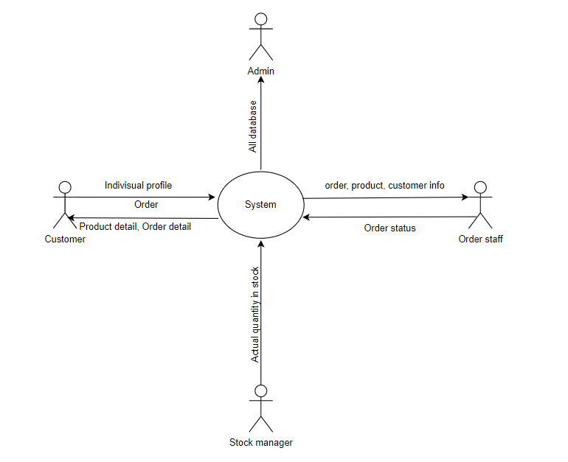

<https://app.diagrams.net/#G1rVlBtZx1UAqijoNMbENlhkJobYdByvfH>

## **System Functions**

### **Screen flow**

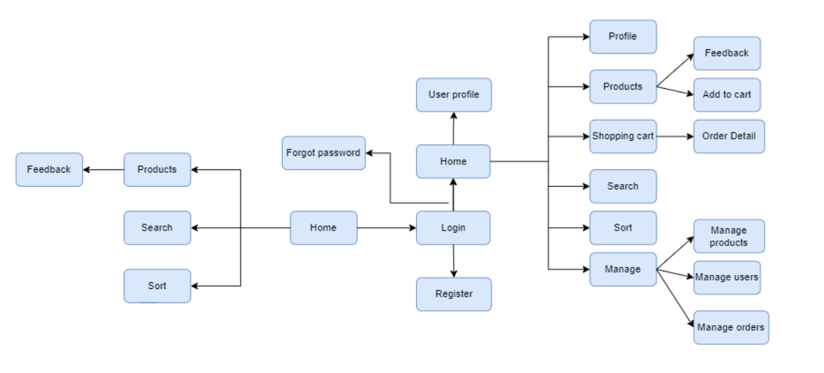

<https://app.diagrams.net/#G1rVlBtZx1UAqijoNMbENlhkJobYdByvfH>

### **Screen Details**

| **#** | **Feature** | **Screen** | **Description** |
| --- | --- | --- | --- |
| 1 | Register | Register | Create a new account. |
| 2 | Authentication | Login, LogOut | Login and sign up for users. |
| 3 | Forgot password | Forgot password | User enter email, system will send a code OTP to verify |
| 4 | View profile | Profile | View user profile |
| 5 | Search product | Search | Search and display the product the user wants to find |
| 6 | Sort product | Sort | sort products by criteria |
| 7 | View product detail | Product Detail | Display detail of product |
| 8 | View Shopping cart | Shopping Cart | Display items in cart |
| 9 | Buy product | Order | Create order |
| 10 | Manage Product | Add Product  Update Product  Delete Product | CRUD application for Product |
| 12 | Manage Order | Add Order  Update Order | CRUD application for Order |
| 13 | Manage User | Add User  Update User  Delete User | CRUD application for User |
| 14 |  |  |  |

### **User Authorization**

| **Role** | **Name** | **Description** |
| --- | --- | --- |
| 1 | Admin | Manage all purchases, products, users |
| 2 | Order staff | Check order status  Check quantity on the web  Manage customer |
| 4 | Stock manager | Check the actual quantity in stock |
| 5 | Customer | Buyer |

| **Screen** | **Role 1** | **Role 2** | **Role 3** | **Role 4** |
| --- | --- | --- | --- | --- |
| Home | x | x | x | x |
| Login, Logout, Register | x | x | x | x |
| View profile | x | x | x | x |
| View product, shopping cart | x | x | x | x |
| Query all data | x |  |  |  |
| Query own data | x | x | x | x |
| Query managed data | x | x | x |  |
| Add new data | x | x | x |  |
| Update all Data | x |  |  |  |
| Update own data | x | x | x | x |
| Update managed data | x | x | x |  |
| Delete data | x |  |  |  |
| List user | x | x |  |  |
| List product | x | x | x |  |
| List order | x | x |  |  |

### **Non-screen function**

| **#** | **Feature** | **System Function** | **Description** |
| --- | --- | --- | --- |
| 1 | Send OTP |  | Send OTP to mail to verify forgetting password |
| 2 | Login with Facebook and Gmail |  | Login by Facebook account or Gmail account |

## 

## **Entity Relationship Diagram**

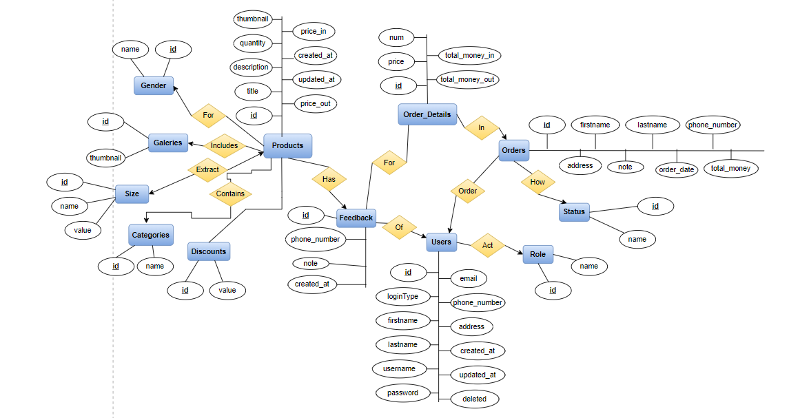

<https://app.diagrams.net/#G1rVlBtZx1UAqijoNMbENlhkJobYdByvfH>

### **Entity Description**

| **#** | **Entity** | **Description** |
| --- | --- | --- |
| 1 | Users | Include admin, order staff, stock manager, customer |
| 2 | Products | Products sold on the web |
| 3 | Orders | Order when buying |
| 4 | Order_Details | Detail of each items in order |
| 5 | Feedbacks | Feedback of customer for each product |
| 6 | Categories | Categories of product |
| 7 | Genders | Product classification criteria |
| 8 | Sizes | Size of product |
| 9 | Discounts | Discount based on order value |
| 10 | Galeries | Contain photos of products |
| 11 | Roles | Role of user |
| 12 | Status | Status of order |

# **II.** **Functional Requirements**

1. **Authentication**
2. **Register**

* Trigger: User indicates that he wants to register a new account.
* Description: Users can use this function when registering a new account.
* Detail: when users click to Register button, the system will lead the user to screen of register and request user enter some information to create an account.
* Screen: As below

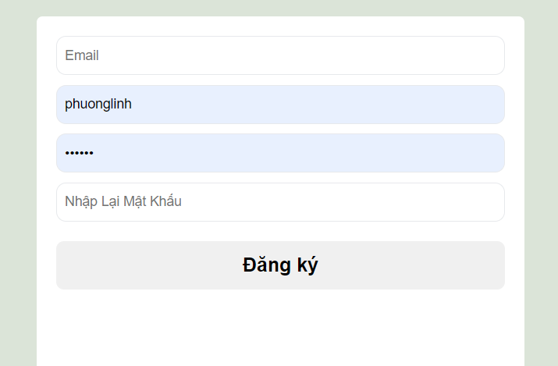

1. **Login**

* Trigger: User indicate that he want to login to the system
* Description: Users can use this function when login to the system.
* Detail: when users click to login, system will request the user to enter username and password. Besides, user can login by Facebook or Gmail account.
* Screen: As below

1. **Forgot password**

**-** Trigger: User indicate that he forgot password

* Description: Users can use this function when forgot password.
* Detail : When users click the button “Forgot password”, the system will path to another screen and request users to enter the email If the email is not in the database, the screen shows a notification “wrong email”. If the email is correct, the system will send OTP to that email. Users enter the sent email to change password.
* Screen: As below

1. **View home screen**
2. **Home**

* Description: Users can use this function to view the home of the web.
* Detail : When users access the web, home will be on screen with some product in the database classified following some criteria as best seller, featured products,....
* Screen: As below

**3. View shop screen**

* Description: User can use this function to view more extensive and detailed products by category, price, search, and sort by themselves.
* Detail : When users access the label “shop” in home page. The system will redirect to the shop page and display all the products. on this page, user can search for products by title, products of each category, price, gender, size, etc... Also user can sort products by criteria prices in ascending, descending, A-Z,Z-A...There is pagination by quantity
* Screen: As below

**4. View product detail**

1. **Product detail**

* Trigger: User want to view detail of product
* Description: Users can use this function to view details of products.
* Detail : When users click to a product, information about that product will be displayed containing name, price, description, feedback, … those saved in the database.
* Screen: As below

**5. Profile**

1. **View profile**

* Trigger: User want to view own profile
* Description: Users can use this function to view their profile
* Detail : When users click the “Profile” button, information about the user will be displayed containing username, email , firstname, last name, …those saved in the database.
* Screen: As below

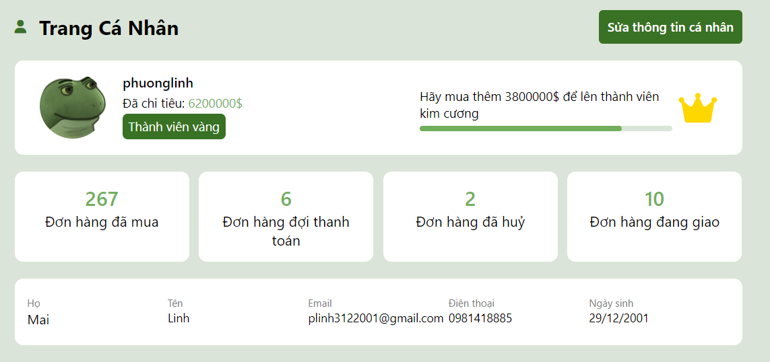

1. **Update profile**

* Trigger: User want to update own profile
* Description: Users can use this function to update their profile
* Detail : When users click the “Change Individual Information” button, the screen will display some information and permit users to change information that can change.
* Screen: As below

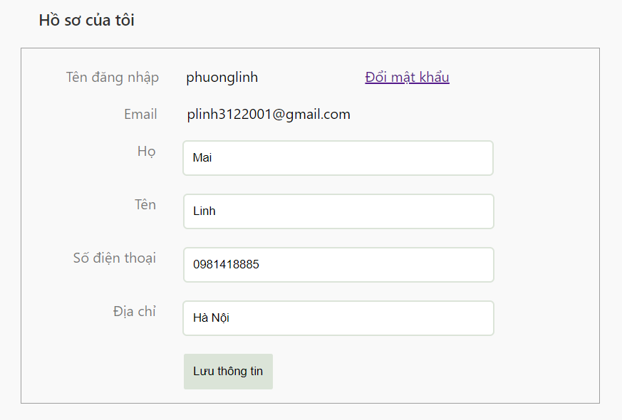

1. **Change password**

* Trigger: User want to change account password
* Description: Users can use this function to change their password
* Detail : When the user is on the “Change Individual Information” screen, then click to “Change Password” , another screen will appear and request user input recent password and new password.
* Screen: As below

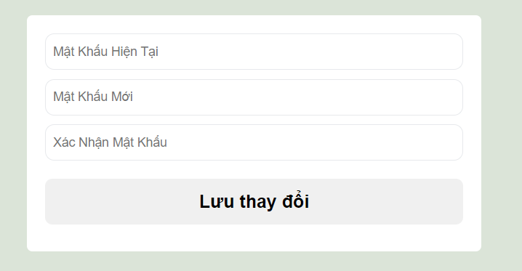

**6. Manage**

1. **Manage product**

* Description: Users have the role of admin, order staff, stock manager can use this function to manage products.

| Action | Role 1 | Role 2 | Role 3 |
| --- | --- | --- | --- |
| Add | x |  | x |
| Querry | x | x | x |
| Update | x | x | x |
| Delete | x |  |  |

*Role 1: admin, role 2: order staff, role 3: stock manager*

* Detail : When users click to manage a product, a list of products will be displayed. When clicking into a product, information saved in the database about that product will be displayed. Users can CRUD with products.
* Screen: As below

1. **Manage user**

* Description: Only users who have the role of admin and order staff can use this function to manage users.

| Action | Role 1 | Role 2 |
| --- | --- | --- |
| Add | x |  |
| Querry | x | x |
| Update | x |  |
| Delete | x |  |

*Role 1: admin, role 2: order staff*

* Detail : When users click to manage users, list products will be displayed. When clicking into a user, information saved in the database about that user will be displayed. Users can CRUD with accounts.
* Screen: As below

1. **Manage order**

* Description: Only users who have the role of admin and order staff can use this function to manage orders.

| Action | Role 1 | Role 2 |
| --- | --- | --- |
| Add | x | x |
| Querry | x | x |
| Update | x | x |
| Delete | x |  |

*Role 1: admin, role 2: order staff*

* Detail : When users click to manage order, list products will be displayed. When clicking into a user, information saved in the database about that user will be displayed. Users can CRUD with orders.
* Screen: As below

**6. Shopping cart**

1. **Add product to cart**

* Description: User can add item into shopping cart
* Detail : When User clicks “Add an item”, the system will add that item to the cart, User can choose the quantity and size of the product.
* Screen: As below

1. **Proceed to checkout**

* Description:
* Detail : after add an item to the cart, User can click Shopping cart icon (or after add to card an item, the system will lead User to the cart), then User can fill User’s information or edit User’s information,choose payment methods .After that, click “Proceed to checkout to complete the order.
* Screen: As below

1. **Manage order**

* Description:
* Detail :
* Screen: As below